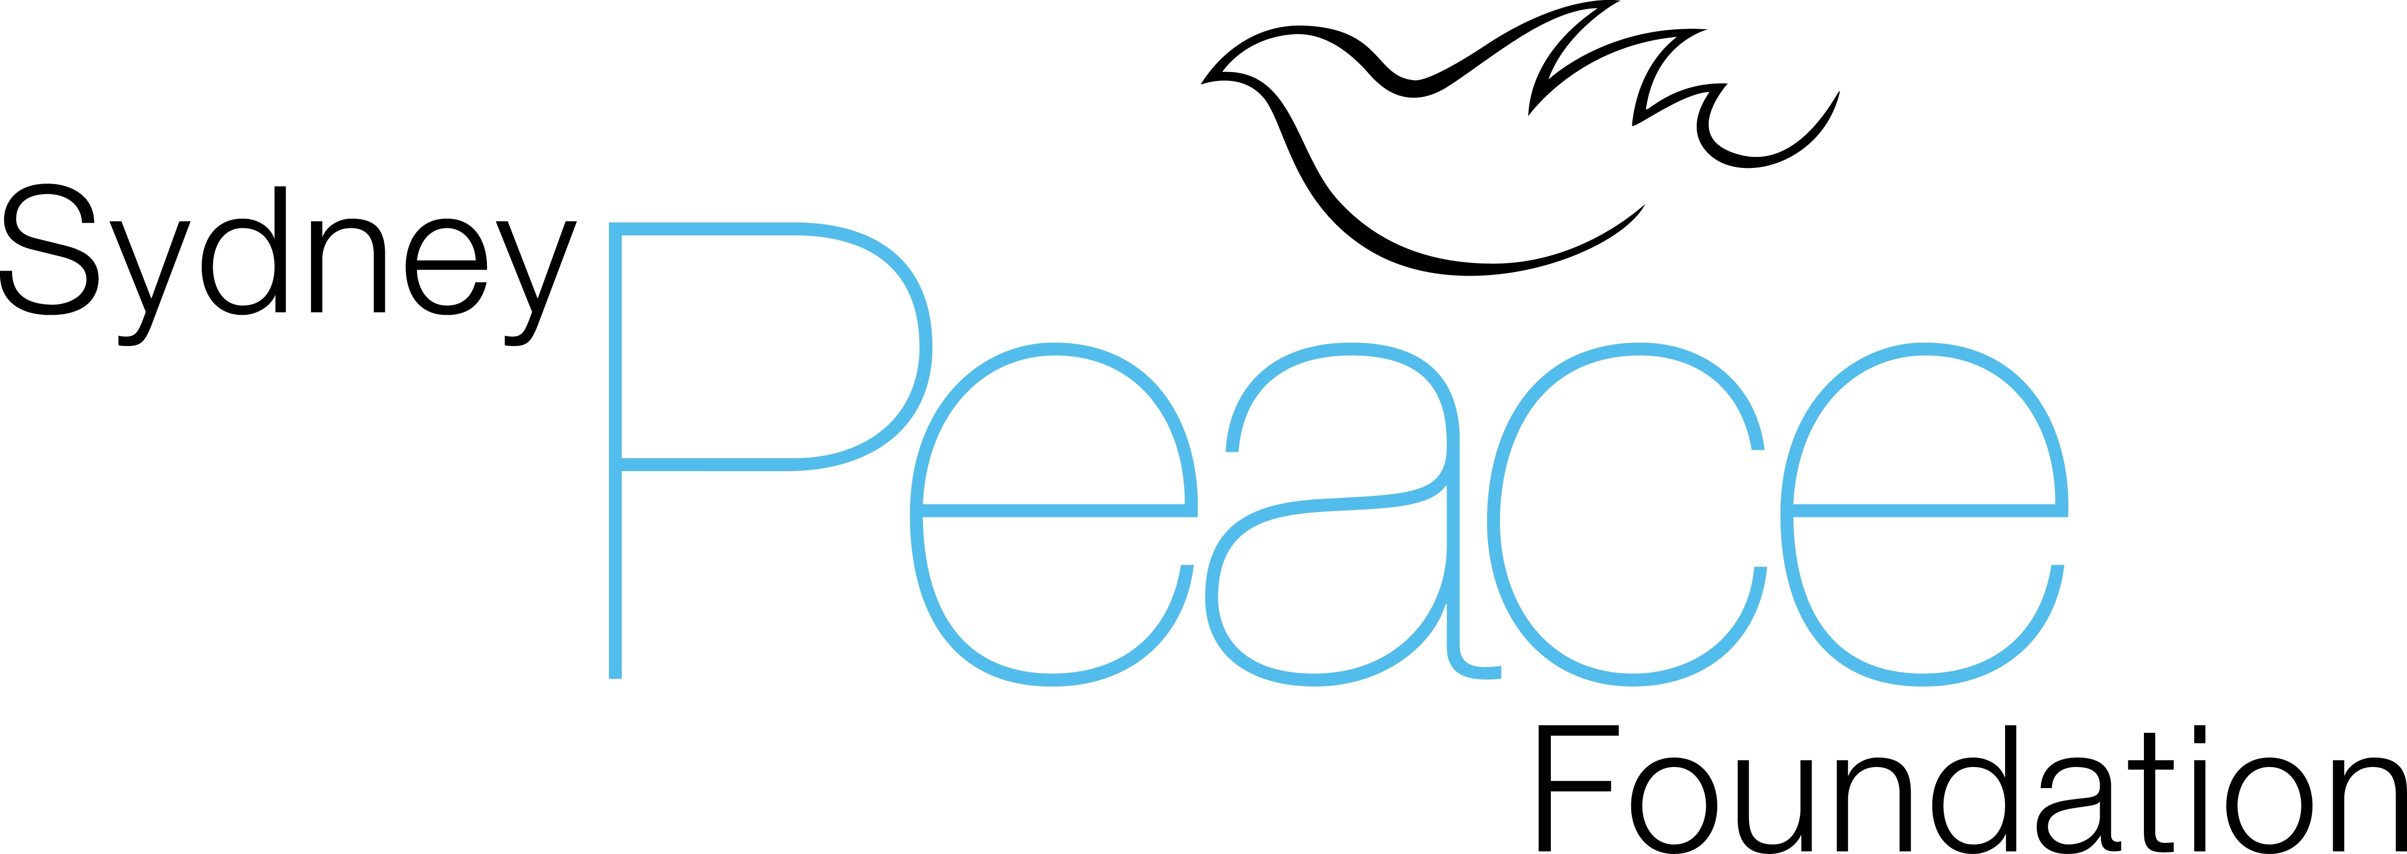
MEDIA RELEASE
Wednesday, 25 July 2012

Morgan Tsvangirai a “hero”, Sekai Holland a “heroine”:
optimism about Zimbabwe
Australian Prime Minister Julia Gillard’s support for Morgan Tsvangirai, Prime Minister of Zimbabwe, and Mr Tsvangiriai’s unwavering commitment to reconciliation for his people are optimistic signs for the future Zimbabwe. According to Mr Tsvangiriai, the Australian government’s possible lifting of sanctions would also be helpful, even if controversial.
On an official visit to Australia, Mr Tsvangirai’s says he cannot afford to “look back and be acrimonious”.
Professor Stuart Rees, Chair of the Sydney Peace Foundation, who attended Monday’s private lunch at Parliament House for the Zimbabwean Prime Minister, comments,
“The Australian Prime Minister’s support for democracy and human rights was an invaluable recognition of the courage shown by members of the Movement for Democratic Change in Zimbabwe by cooperating with President Mugabe. Making peace with your enemies is much more significant than being in solidarity with your friends”.
The Sydney Peace Foundation is giving specific support to reconciliation in Zimbabwe in its choice of Co-Minister for Reconciliation, Healing and Integration, Zimbabwean Senator Sekai Holland, as the 2012 recipient of the Sydney Peace Prize.
During Monday’s lunch Prime Minister Gillard praised Mr Tsvangirai as “a hero”, placing him among the ranks of other leaders who’ve made a difference in human rights over the decades. Rees says, “If Morgan Tsvangirai is a hero, then Sekai Holland is a heroine - they have both suffered torture, have both shown enormous courage and they are both working with their former enemies to achieve a more just future for Zimbabwe”.
Senator Sekai Holland was announced as the 2012 Sydney Peace Prize recipient in May this year at a reception in Harare, Zimbabwe, hosted by the Australian Ambassador to Zimbabwe and attended by Mr Tsvangirai.
Senator Holland will give the City of Sydney Peace Prize Lecture in Sydney’s Town Hall on November 7 and will receive the Sydney Peace Prize at a Gala Dinner on November 8th.

Media Enquiries:
Melissa McCullough
Media and Publicity Officer | Sydney Peace Foundation
0432 861 653
melissa.mccullough@sydney.edu.au
www.sydneypeacefoundation.org.au

